# React

## Lesson-1

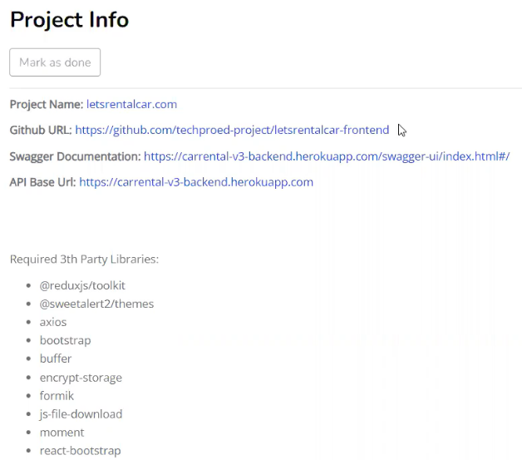

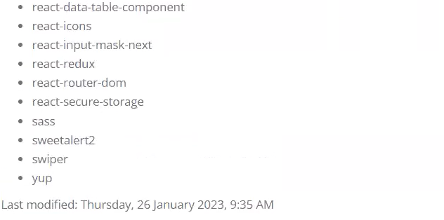

1. Create project with npx create-react-app car-rent
2. Cd car rent
3. Npm start

It opens car-rent project in local host http://localhost:3000/

1. Create folder structure as

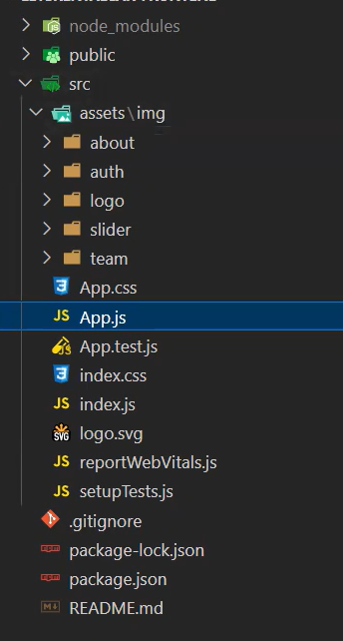

1. Gereksiz folder/file kaldir

App.css, App.test.js, index.css, logo.svg

1. App.js de rafce ile sifirlayalim
2. import React from 'react'
3. const App = () => {
4. return (
5. <div>App</div>
6. )
7. }
8. export default App
9. index.js den

import './index.css';

satirini kaldir.

1. Src altinda api folder yap. Butun axios islemleri yani data cekme burada olacak
2. 1c0h13m:components, helpers, pages, router, store, templates folderlarini src altinda olustur.
3. The structure to follow
4. Assets folder da scss yap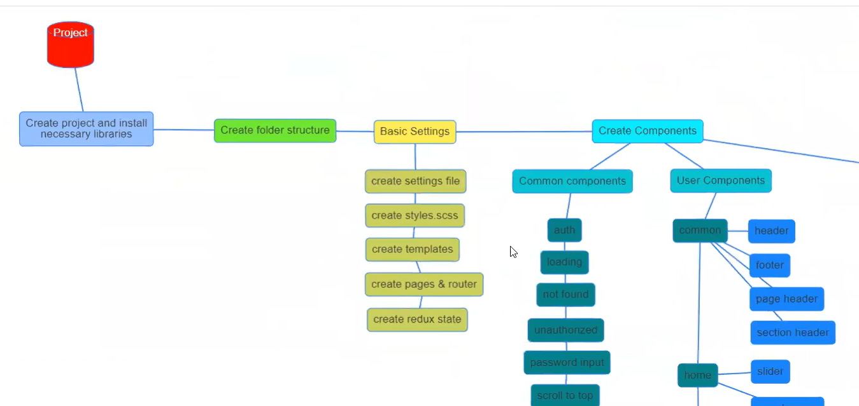
5. Basic settings yapalim

helpers/settings.js yap

bu bizim ayar dosyamiz..

1. Styles.scss olustur.(scss folder da)

Icerisinde

/*LIBRARIES */

// bunu index.js de koymak mumkun

@import "bootstrap/scss/bootstrap";

1. _variables.scss ve _mixins.scss dosyalarini olsutur

_mixins icerisine

@mixin reset-list {

  list-style: none;

  padding: 0;

  margin: 0;

}

@mixin flexbox(

  $direction: row,

  $justify-content: flex-start,

  $align-items: flex-start,

  $gap: 0

) {

  display: flex;

  justify-content: $justify-content;

  flex-direction: $direction;

  align-items: $align-items;

  gap: $gap;

}

1. Renk kodlarini ekle(_variables.scss )

$color1: rgb(123, 0, 145);

$color2: rgb(203, 179, 0);

$color3: rgb(116, 116, 116);

$color4: rgb(237, 237, 237);

$color5: rgb(123, 0, 145, 0.5);

$color6: rgb(203, 179, 0, 0.5);

1. Templates folder da.
2. admin-template.js ve user-template.js dosyalarini olusturalim
3. import React from "react";
4. const AdminTemplate = () => {
5. return <div>AdminTemplate</div>;
6. };
7. export default AdminTemplate;
8. 35dak.

Sayfamizda user ve admini gorecegi kisimlarda ayni olan yerleri templatede tanimlayacagiz. Genelde ust ve alt ayni oldugu icin buralarda header ve footer component olusturarak yapabiliriz. Bunun icin component altinda admin, user, common folder olusturalim. Admin componnetleri admin folder …

Bunlarin altina web de ki her sayfa icin bir folder yapacagiz. Yani user un kullanacagi sayfalarin her biri icin bir folder var ve. Bu sayfalarin ortak componentleri icinde footer ve common folder var.

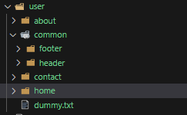

Dak 36

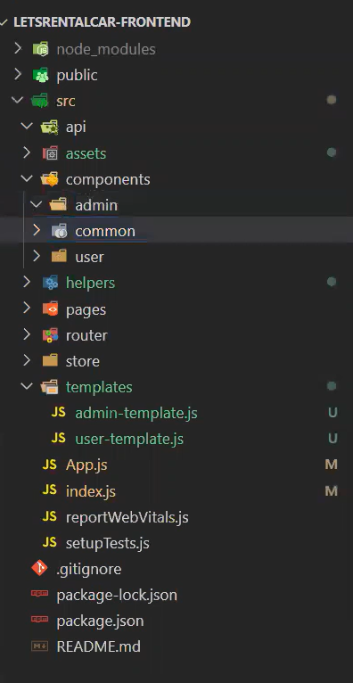

1. header ve footer folderlarda header.js ve footer.js oluturalim

import React from "react";

const Header = () => {

  return <div>Header</div>;

};

export default Header;

import React from "react";

const Footer = () => {

  return <div>Footer</div>;

};

export default Footer;

1. Header ve Footer componentler UserTemplate component ekle

import React from "react";

import Header from "../components/user/common/header/header";

import Footer from "../components/user/common/footer/footer";

const UserTemplate = () => {

  return (

    <>

      <Header />

      <Footer />

    </>

  );

};

export default UserTemplate;

1. childeren arg user template ekle

import React from "react";

import Header from "../components/user/common/header/header";

import Footer from "../components/user/common/footer/footer";

const UserTemplate = ({ childeren }) => {

  return (

    <>

      <Header />

      {childeren}

      <Footer />

    </>

  );

};

export default UserTemplate;

boylelikle UserTemplate ile sarmalladigimiz hersey Header ve Footer arasina koyulabilir. Her yerde Header ve Footer import etmeye gerek kalmayacak

1. pages folder git ve admin, user, common folderlari olustur.

Pages ile components yapisi ayni cunku burada her page karsilik gelen componentler olacak

1. Dikkat edilirse pages ile component yapisi ayni olur
2. User icerine homepage.js yap ve App.js HomePage component ekle

import React from "react";

import HomePage from "./pages/user/home-page";

const App = () => {

  return (

    <>

      <HomePage />

    </>

  );

};

export default App;

1. Homepage component git ve bunu usertemplate ile sarmalla

import React from "react";

import UserTemplate from "../../templates/user-template";

const HomePage = () => {

  return <UserTemplate>HomePage</UserTemplate>;

};

export default HomePage;

1. Ve app son hali
2. 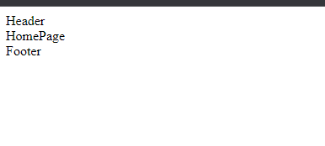48m Simdi sayfalarimizi olusturacagiz. about-page.js olusturalim, contact-page.js, vehicles-page.js,vehicles-details-page.js,auth-page.js, reservations-page.js, reservation-details-page.js, profile-page.js, privacy-policy-page.js. User icin 10 sayfa oldu.

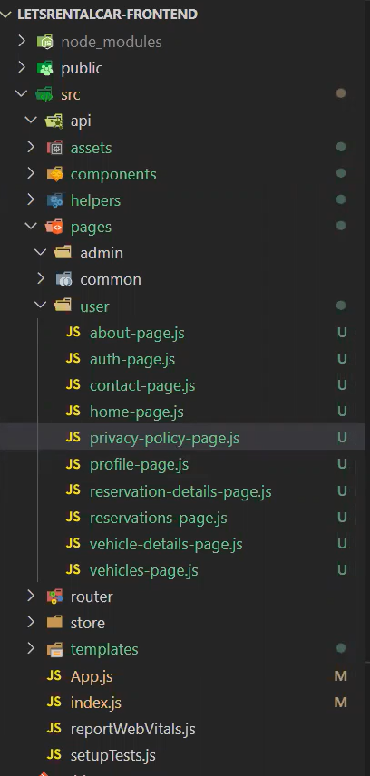

import React from "react";

const About = () => {

  return <UserTemplate>About</UserTemplate>;

};

export default About;

import React from "react";

const Auth = () => {

  return <div>Auth</div>;

};

export default Auth;

import React from "react";

const ContactPage = () => {

  return <UserTemplate>ContactPage</UserTemplate>;

};

export default ContactPage;

import React from "react";

const PrivacyPolicyPage = () => {

  return <UserTemplate>PrivacyPolicyPage</UserTemplate>;

};

export default PrivacyPolicyPage;

import React from "react";

import UserTemplate from "../../templates/user-template";

const ProfilePage = () => {

  return <UserTemplate>ProfilePage</UserTemplate>;

};

export default ProfilePage;

import React from "react";

import UserTemplate from "../../templates/user-template";

const ReservationDetailsPage = () => {

  return <UserTemplate>ReservationDetailsPage</UserTemplate>;

};

export default ReservationDetailsPage;

import React from "react";

import UserTemplate from "../../templates/user-template";

const ReservationPage = () => {

  return <UserTemplate>ReservationPage</UserTemplate>;

};

export default ReservationPage;

import React from "react";

import UserTemplate from "../../templates/user-template";

const VehicleDetailsPage = () => {

  return <UserTemplate>VehicleDetailsPage</UserTemplate>;

};

export default VehicleDetailsPage;

import React from "react";

import UserTemplate from "../../templates/user-template";

const VehiclesPage = () => {

  return <UserTemplate>VehiclesPage</UserTemplate>;

};

export default VehiclesPage;

1. Auth page common tasiyalim daha mantikli ve burada asagidaki pageleri olusturalim

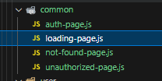 bu pagelein kodlari

import React from 'react'

const LoadingPage = () => {

  return (

    <div>LoadingPage</div>

  )

}

export default LoadingPage

import React from "react";

import React from "react";

import UserTemplate from "../../templates/user-template";

const NotFoundPage = () => {

  return <UserTemplate>NotFoundPage</UserTemplate>;

};

export default NotFoundPage;

import React from "react";

import UserTemplate from "../../templates/user-template";

const UnauthorizedPage = () => {

  return <UserTemplate>UnauthorizedPage</div>;

};

export default UnauthorizedPage;

1. Router olusturulmasi

custom-routes.js olusturalim ve BrowserRouter ile sarmalla

oncesinde npm i react-router-dom kurmalisin.

import React from "react";

import { BrowserRouter } from "react-router-dom";

const CustomRoutes = () => {

  return <BrowserRouter>CustomRoutes</BrowserRouter>;

};

export default CustomRoutes;

ve dolduralim  
import React from "react";

import React from "react";

import { BrowserRouter, Routes, Route } from "react-router-dom";

import HomePage from "../pages/user/home-page";

import AboutPage from "../pages/user/about-page";

import ContactPage from "../pages/user/contact-page";

import VehiclesPage from "../pages/user/vehicles-page";

import VehicleDetailsPage from "../pages/user/vehicle-details-page";

import UnauthorizedPage from "../pages/common/unauthorized-page";

import PrivacyPolicyPage from "../pages/user/privacy-policy-page";

import AuthPage from "../pages/common/auth-page";

import ProfilePage from "../pages/user/profile-page";

import ReservationPage from "../pages/user/reservation-page";

import ReservationDetailsPage from "../pages/user/reservation-details-page";

import NotFoundPage from "../pages/common/not-found-page";

const CustomRoutes = () => {

  return (

    <BrowserRouter>

      <Routes>

        <Route path="/">

          <Route index element={<HomePage />} />

          <Route path="about" element={<AboutPage />} />

          <Route path="contact" element={<ContactPage />} />

          <Route path="privacy-policy" element={<PrivacyPolicyPage />} />

          <Route path="auth" element={<AuthPage />} />

          <Route path="unauthorized" element={<UnauthorizedPage />} />

          <Route path="vehicles">

            <Route index element={<VehiclesPage />} />

            <Route index=":vehicleId" element={<VehicleDetailsPage />} />

          </Route>

          <Route path="user">

            <Route index element={<ProfilePage />} />

            <Route path="reservations">

              <Route index element={<ReservationPage />} />

              <Route

                path=":reservationId"

                element={<ReservationDetailsPage />}

              />

            </Route>

          </Route>

        </Route>

        <Route path="admin"></Route>

        <Route path="*" element={<NotFoundPage />}></Route>

      </Routes>

    </BrowserRouter>

  );

};

export default CustomRoutes;

:reservationID gibi tanimlananlarda : isareti bunun degisken oldugunu belirtir.

Yani user/reservations/1234 gecerli bir path dir.

index ise parent in pathinin kullanilcagina gosterir.

ve simdi kullanalim. App.js de HomePage kaldir ve CustomRoutes yerlestir

import React from "react";

import CustomRoutes from "./router/custom-routes";

const App = () => {

  return (

    <>

      <CustomRoutes />

    </>

  );

};

export default App;

1. 1h48m50s Redux state olusturulmasi

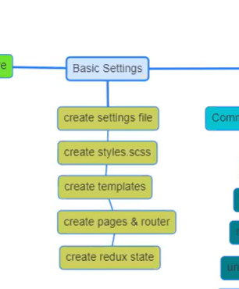

1. Store folder da slices ve index.js olustur.slice icerisinde auth-slice.js olsuturalim

npm i @reduxjs/toolkit kuralim

slice olsutur

import { createSlice } from "@reduxjs/toolkit";

// create slice yap

// name

// initial state

// reducer tanimla

// actions olustur

// slice export et

export const authSlice = createSlice({

  name: "auth",

  initialState: {

    isUserLogin: false,

    user: {},

  },

  reducers: {

    loginSuccess: (state, action) => {

      state.isUserLogin = true;

      state.isUserLogin = true;

      state.user = action.payload;

    },

    loginFailled: (state) => {

      state.isUserLogin = false;

      state.user = {};

    },

    logout: (state, action) => {

      state.isUserLogin = false;

      state.user = {};

    },

  },

});

export const { loginSuccess, loginFailled, logout } = authSlice.actions;

export default authSlice.reducer;

slice config yap (store/index.js)

import { configureStore } from "@reduxjs/toolkit";

import authSlice from "./slices/auth-slice";

export default configureStore({

    reducer:{

        auth: authSlice

    }

})

Ve ana index.js de <App> provider icersine al. npm i react-redux kur

import React from "react";

import ReactDOM from "react-dom/client";

import { Provider as StoreProvider } from "react-redux";

import App from "./App";

import reportWebVitals from "./reportWebVitals";

import store from "./store";

const root = ReactDOM.createRoot(document.getElementById("root"));

root.render(

  <React.StrictMode>

    <StoreProvider store={store}>

      <App />

    </StoreProvider>

  </React.StrictMode>

);

// If you want to start measuring performance in your app, pass a function

// to log results (for example: reportWebVitals(console.log))

// or send to an analytics endpoint. Learn more: https://bit.ly/CRA-vitals

reportWebVitals();

1. 2h22m50s

Component create yapacagiz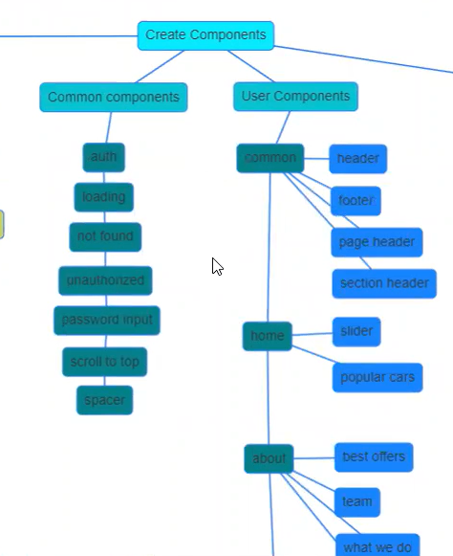

### Header yapimi

header.js dolduralim. Asagidaki header olusturcagiz



npm i react-bootstrap kuralim

import React from "react";

import { Container } from "react-bootstrap";

const Header = () => {

  return <Container>Header</Container>;

};

export default Header;

ve import "./assets/scss/styles.scss";

veya

import "../node_modules/bootstrap/scss/bootstrap.scss";

index.js ‘e import et.

Bu arada npm i sass kurulmali

npm i bootstrap

npm rebuild node-sass

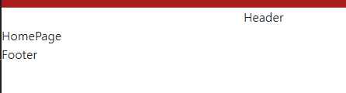

Google fontlari kullanalim- nunuto fontu

@import url('https://fonts.googleapis.com/css2?family=Nunito+Sans:ital,opsz,wght@0,6..12,200;1,6..12,200&family=Nunito:ital,wght@0,500;1,500&display=swap');

Style.scss ekleyelim

npm i styled-components kuralim

<https://www.npmjs.com/package/styled-components>

adresinden bakabiliriz.

Nunito kullanmak icin

@import "./variables"

Styles.css koy ve

Normalde bootstrap/scss/_variables.scss de tanimlanan renkleri degistirmek icin

_variables.scss dosyasi

$color1: rgb(123, 0, 145);

$color2: rgb(203, 179, 0);

$color3: rgb(116, 116, 116);

$color4: rgb(237, 237, 237);

$color5: rgb(123, 0, 145, 0.5);

$color6: rgb(203, 179, 0, 0.5);

/*BOOTSTRAP */

$primary: $color1; // bootstrap in orjinal degerlerini degistiriyoruz

$secondary: $color2;

$font-family-sans-serif: "Nunito";

Ve sytles.scss dosyasi

/*LIBRARIES */

@import url("https://fonts.googleapis.com/css2?family=Nunito+Sans:ital,opsz,wght@0,6..12,200;1,6..12,200&family=Nunito:ital,wght@0,500;1,500&display=swap");

@import "./variables";

@import "bootstrap/scss/bootstrap";

// body {

//   font-family: "Times New Roman", Times, serif;

//   font-size: xx-large;

// }

1. Logo ekle, menubar.js ve topbar.js olustur
2. import React from "react";
3. const Topbar = () => {
4. return <div>Tobbar</div>;
5. };
6. export default Topbar;

import React from "react";

const Menubar = () => {

  return <div>Menubar</div>;

};

export default Menubar;

import React from "react";

import { Container } from "react-bootstrap";

// import styled from "styled-components";

import logo from "../../../../assets/img/logo/logo.png";

import { settings } from "../../../../helpers/settings";

import Menubar from "./menubar";

import Topbar from "./topbar";

const Header = () => {

  return (

    <>

      <Container>

        <div className="header">

          <div className="logo">

            <img src={logo} alt={settings.siteName} className="img-fluid" />

          </div>

        </div>

        <div className="menus">

          <Menubar />

          <Topbar />

        </div>

      </Container>

    </>

  );

};

export default Header;

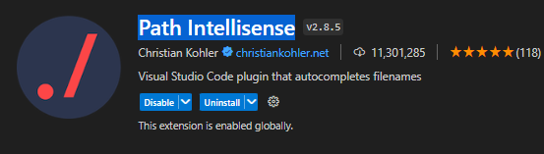

Eklenti kuruldu

ul.social-bar>li*5 : bu nu yazarak kisa yoldan 5 tane ul oluturur. Dene gor

    <ul className="social-bar">

        <li></li>

        <li></li>

        <li></li>

        <li></li>

        <li></li>

    </ul>

ul.social-bar>li*5 >a

<ul className="social-bar">

    <li><a href=""></a></li>

    <li><a href=""></a></li>

    <li><a href=""></a></li>

    <li><a href=""></a></li>

    <li><a href=""></a></li>

</ul>

npm i react-icons kur

toolbar.js

import React from "react";

import {

  FaFacebook,

  FaInstagram,

  FaLinkedin,

  FaTwitter,

  FaYoutube,

  FaHeadphonesAlt,

  FaRegEnvelopeOpen,

} from "react-icons/fa";

import { settings } from "../../../../helpers/settings";

const Topbar = () => {

  return (

    <div className="topbar">

      <ul className="contact-bar">

        <li>

          <a href={`tel:${settings.phone1}`}>

            {" "}

            <FaHeadphonesAlt />

            {settings.phone1}

          </a>

        </li>

        <li>

          <a href={`mailto:${settings.email}`}>

            {" "}

            <FaRegEnvelopeOpen />

            {settings.email}

          </a>

        </li>

      </ul>

      <ul className="social-bar">

        <li>

          <a href="https://instagram.com">

            <FaInstagram />

          </a>

        </li>

        <li>

          <a href="https://facebook.com">

            <FaFacebook />

          </a>

        </li>

        <li>

          <a href="https://linkedin.com">

            <FaLinkedin />

          </a>

        </li>

        <li>

          <a href="https://twitter.com">

            <FaTwitter />

          </a>

        </li>

        <li>

          <a href="https://youtube.com">

            <FaYoutube />

          </a>

        </li>

      </ul>

    </div>

  );

};

export default Topbar;

### Menubar yapimi

React bootstrap dan navbar aliyoruz

npm i react-bootstrap dan nav kopyala ve asaagidaki degisikleri yap

menubar.js

import React from "react";

import Nav from "react-bootstrap/Nav";

import Navbar from "react-bootstrap/Navbar";

import Container from "react-bootstrap/Container";

import { Link } from "react-router-dom";

import { Button } from "react-bootstrap";

const Menubar = () => {

  return (

    <div className="menubar">

      <Navbar expand="lg">

        <Container>

          <Navbar.Toggle aria-controls="basic-navbar-nav" />

          <Navbar.Collapse id="basic-navbar-nav">

            <Nav className="me-auto">

              <Nav.Link as={Link} to="/">

                Home

              </Nav.Link>

              <Nav.Link as={Link} to="vehicles">

                Vehicles

              </Nav.Link>

              <Nav.Link as={Link} to="/about">

                About

              </Nav.Link>

              <Nav.Link as={Link} to="/contact">

                Contact

              </Nav.Link>

            </Nav>

            <div className="register">

              <Button variant="secondary" as={Link} to="/auth">

                Register

              </Button>

            </div>

          </Navbar.Collapse>

        </Container>

      </Navbar>

    </div>

  );

};

export default Menubar;

header bicimledirmek icin css yazilacak ve bunlari header.scss koyalim

ve bunu header.js import edelim

import "./header.scss";

## Lesson-2

### Responsive design: Ekran kucultulunce ne olur?

Ekran cok kuculdugunde logo, tel vesaire yer degistirecek. Telefonlar logo altina gelecek vesaire

Header.js

  @media (max-width: 992px) {

    @include m.flexbox(row, space-between, stretch);

  }

Yukaridaki satir ile ekran genisligi 992 dustugunde tel vb logo altina gelmesi saglandi

    .topbar {

      @include m.flexbox(row, space-between, center, 1rem);

      flex: 1;

      border-bottom: 1px dotted v.$color3;

      @media (max-width: $breakpoint) {

        border-bottom: 0px;

      }

Yukaridaki media ile ekran daraldiginda cizgiyi kaldirdik

Ayrica email kaldiracagiz, menuyu logo yanina alacagiz

        <li>

          <a href={`mailto:${settings.email}`}>

            <FaRegEnvelopeOpen />

            <span className="d-none d-md-inline">{settings.email}</span>

          </a>

        </li>

Sari yerde class ismi ile gizlemeyi basardik

### Footer olusturulmasi

Common/footer/footer.js icerigini dolduracagiz

Footer da 4 sutunluk bir yapi var



footer.scss yap

### ul>li*5>Link:

ile unorderes list altinda 5 item ve her birinin Link’I mevcut

footer.js

import React from "react";

import "./footer.scss";

import { Link } from "react-router-dom";

import { Col, Container, Row } from "react-bootstrap";

import logo from "../../../../assets/img/logo/logo.png";

import {

  MdOutlineHome,

  MdInfoOutline,

  MdOutlineHeadphones,

  MdDirectionsCar,

  MdOutlinePrivacyTip,

} from "react-icons/md";

const Footer = () => {

  return (

    <footer className="footer">

      <Container className="container">

        <Row>

          <Col md={6} lg={3}>

            <Link to="/">

              <img src={logo} alt=""></img>

            </Link>

            <p>

              Check out our new fleet of cars, latest offers, our advantages and

              free extras online. Choose from one of our new car models.

            </p>

          </Col>

          <Col md={6} lg={3}>

            <h2>Quick Links</h2>

            <ul>

              <li>

                <Link to="/">

                  <MdOutlineHome />

                  Home

                </Link>

              </li>

              <li>

                <Link to="/vehicles">

                  <MdDirectionsCar />

                  Vehicles

                </Link>

              </li>

              <li>

                <Link to="/about">

                  <MdOutlineHeadphones />

                  About us

                </Link>

              </li>

              <li>

                <Link to="/contact">

                  <MdInfoOutline />

                  Contact us

                </Link>

              </li>

              <li>

                <Link to="/privacy-policy">

                  <MdOutlinePrivacyTip />

                  Privacy policy

                </Link>

              </li>

            </ul>

          </Col>

          <Col md={6} lg={3}>

            <h2>Working Hours</h2>

            <ul>

              <li>Mo-Fri: 09:00AM - 09:00PM</li>

              <li>Saturday: 09:00AM - 07:00PM</li>

              <li>Sunday: 09:00AM - 05:00PM</li>

            </ul>

          </Col>

          <Col md={6} lg={3}>

            <h2>Contact us</h2>

          </Col>

        </Row>

      </Container>

    </footer>

  );

};

export default Footer;

mevcut durum



Buradaki contact us kismini component olarak yapalim

contact-info.js ve contact-info.scss olusturuldu.

Footer.js

import React from "react";

import "./footer.scss";

import { Link } from "react-router-dom";

import { Col, Container, Row } from "react-bootstrap";

import logo from "../../../../assets/img/logo/logo.png";

import {

  MdOutlineHome,

  MdInfoOutline,

  MdOutlineHeadphones,

  MdDirectionsCar,

  MdOutlinePrivacyTip,

} from "react-icons/md";

import ContactInfo from "../../contact/contact-info";

const Footer = () => {

  return (

    <footer className="footer">

      <Container className="container">

        <Row>

          <Col md={6} lg={3}>

            <Link to="/">

              <img src={logo} alt=""></img>

            </Link>

            <p>

              Check out our new fleet of cars, latest offers, our advantages and

              free extras online. Choose from one of our new car models.

            </p>

          </Col>

          <Col md={6} lg={3}>

            <h2>Quick Links</h2>

            <ul>

              <li>

                <Link to="/">

                  <MdOutlineHome />

                  Home

                </Link>

              </li>

              <li>

                <Link to="/vehicles">

                  <MdDirectionsCar />

                  Vehicles

                </Link>

              </li>

              <li>

                <Link to="/about">

                  <MdOutlineHeadphones />

                  About us

                </Link>

              </li>

              <li>

                <Link to="/contact">

                  <MdInfoOutline />

                  Contact us

                </Link>

              </li>

              <li>

                <Link to="/privacy-policy">

                  <MdOutlinePrivacyTip />

                  Privacy policy

                </Link>

              </li>

            </ul>

          </Col>

          <Col md={6} lg={3}>

            <h2>Working Hours</h2>

            <ul>

              <li>Mo-Fri: 09:00AM - 09:00PM</li>

              <li>Saturday: 09:00AM - 07:00PM</li>

              <li>Sunday: 09:00AM - 05:00PM</li>

            </ul>

          </Col>

          <Col md={6} lg={3}>

            <h2>Contact us</h2>

            <ContactInfo />

          </Col>

        </Row>

      </Container>

    </footer>

  );

};

export default Footer;

contatc-info.js

import React from "react";

import "./contact-info.scss";

import {

  MdEmail,

  MdLocationOn,

  MdOutlineHeadphones,

  MdOutlinePhonelinkRing,

} from "react-icons/md";

import { settings } from "../../../helpers/settings";

const ContactInfo = () => {

  return (

    <ul>

      <li>

        <MdOutlineHeadphones />

        {settings.phone1}

      </li>

      <li>

        <MdOutlinePhonelinkRing />

        {settings.phone2}

      </li>

      <li>

        <MdLocationOn />

        {settings.address}

      </li>

      <li>

        <MdEmail />

        {settings.email}

      </li>

    </ul>

  );

};

export default ContactInfo;

yukaridakinde bazi degisikler yapildi.

### Home page slider eklenmesi

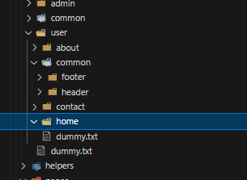

Home folderda slider.js ve slider.scss yap

### Swiper

kutuphanesini kullanacagiz

npm i swiper

[

    {

        "id":1,

        "image":"slider1.jpg",

        "title":"Car Rent Service in Your City",

        "desc":"We offer rental deals at large airports like Norman Y. Mineta San Jose International Airport"

    },

    {

        "id":2,

        "image":"slider2.jpg",

        "title":"Quality cars with Unlimited Miles",

        "desc":"We also have convertible, luxury and premium options if you want a more upscale rental"

    }

]

Slider.js

import React from "react";

import { Swiper, SwiperSlide } from "swiper/react";

import "./slider.scss";

import "swiper/css/navigation";

import "swiper/css/pagination";

import slides from "./slider.json";

const Slider = () => {

  return (

    <Swiper className="slider">

      {slides.map((slide) => (

        <SwiperSlide key={slide.id}>

          <div className="content">

            <h2>{slide.title}</h2>

            <p>{slide.desc}</p>

          </div>

          <img

            src={require(`../../../assets/img/slider/${slide.image}`)}

            alt={slide.title}

          />

        </SwiperSlide>

      ))}

    </Swiper>

  );

};

export default Slider;

slider.scss

.slider {

  .swiper-wrapper {

    .swiper-slide {

      img {

        object-fit: cover;

        width: 100%;

        height: 100vh;

      }

      .content {

        position: absolute;

        top: 50%;

        left: 50%;

        transform: (translate(-50%));

        text-align: center;

      }

    }

  }

}

Ve @import "swiper/css";

Into styles.scss



## Lesson-3

Loading page is added

Not found page is added

Common/ loading component is created as follows

import React from "react";

import { Spinner } from "react-bootstrap";

const Loading = () => {

  return (

    <div className="loading">

      <Spinner animation="border" />

    </div>

  );

};

export default Loading;

15m10sec

Spacer.js eklendi. Bu component componentler arasi bosluk kulanmak icin olusturuldu.

import React from "react";

const Spacer = ({ height = 100 }) => {

  return <div style={{ height: height }}></div>;

};

export default Spacer;

### Slider uzerinde calisma:

Navigation eklendi

import React from "react";

import { Swiper, SwiperSlide } from "swiper/react";

import "./slider.scss";

import "swiper/css/navigation";

import { Navigation } from "swiper/modules";

import slides from "./slider.json";

const Slider = () => {

  return (

    <Swiper navigation={true} modules={[Navigation]} className="slider">

      {slides.map((slide) => (

        <SwiperSlide key={slide.id}>

          <div className="content">

            <h2>{slide.title}</h2>

            <p>{slide.desc}</p>

          </div>

          <img

            src={require(`../../../assets/img/slider/${slide.image}`)}

            alt={slide.title}

          />

        </SwiperSlide>

      ))}

    </Swiper>

  );

};

export default Slider;

46m

### Get our best offer bolumu

Section header olusturma

import React from "react";

import "./section-header.scss";

const SectionHeader = ({ title1, title2, desc }) => {

  return (

    <div className="sectionheader">

      <h2>

        {title1} <span>{title2} </span>

      </h2>

      <p>{desc}</p>

    </div>

  );

};

export default SectionHeader;

@use "../../../../assets/scss/variables" as v;

.sectionheader {

  text-align: center;

  h2 {

    font-weight: 400;

    font-size: 3rem;

    color: v.$color2;

    text-transform: uppercase;

    span {

      font-weight: 800;

    }

  }

  p {

    color: v.$color1;

  }

}

Section-header.scss

@use "../../../../assets/scss/variables" as v;

.sectionheader {

  text-align: center;

  h2 {

    font-weight: 400;

    font-size: 3rem;

    color: v.$color2;

    text-transform: uppercase;

    span {

      font-weight: 800;

    }

  }

  p {

    color: v.$color1;

  }

}

1h15m

Bu bolumu yapacagiz

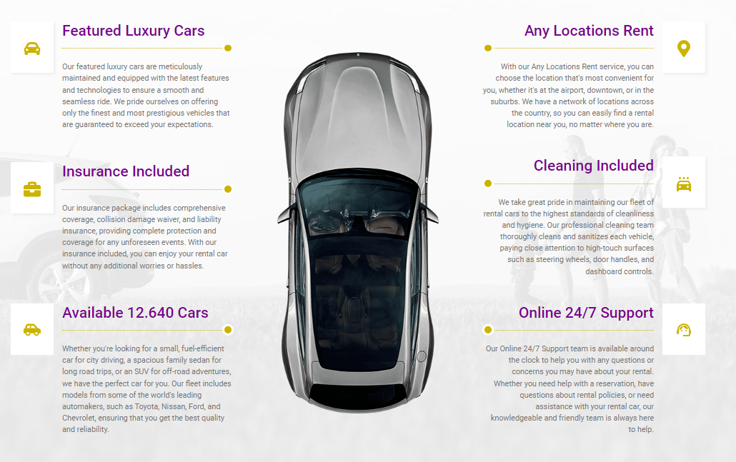

Responsive yapiyida dusunerek bunu 3 kolon yapacagiz

Ayrica arka planda var.

Best-offer.js de devam

Offer-item.js offer-item.scss yapildi

npm i @redux-devtools/core

redux toolkit icin bu dokumana bak  
<https://javascript.plainenglish.io/a-simple-guide-to-the-redux-toolkit-e360e28dcb5c>

<https://blog.logrocket.com/smarter-redux-redux-toolkit/>

### Extra: Redux Toolkit

<https://www.youtube.com/watch?v=u3KlatzB7GM>

1. Create react-app
2. Install react toolkit npm install @reduxjs/toolkit react-redux
3. Src/app, store.js where you keep all state.
4. Store.js : codef

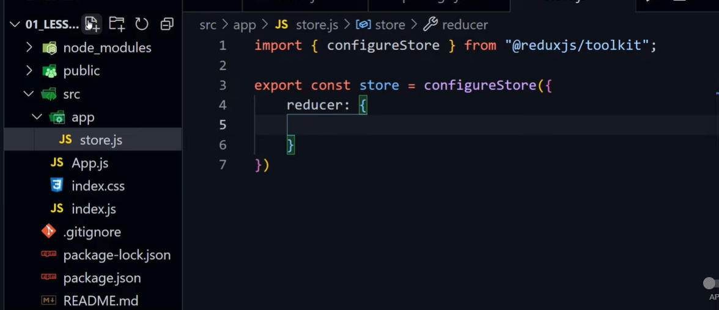

Got o index.js , import to store and use provider to wrap it

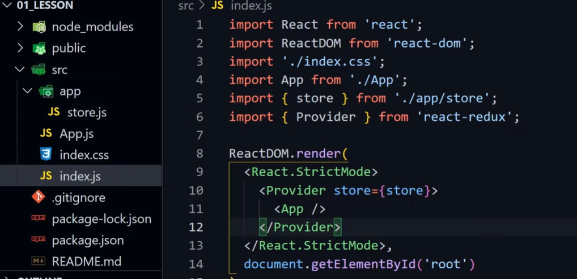

Creating slice for counter

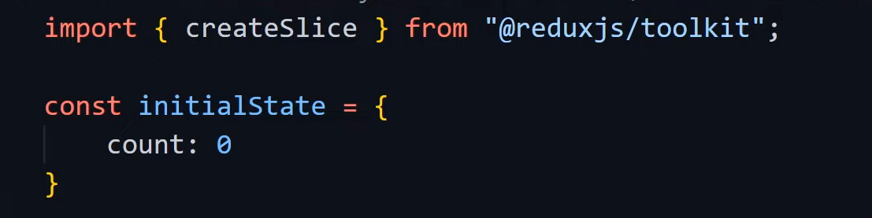

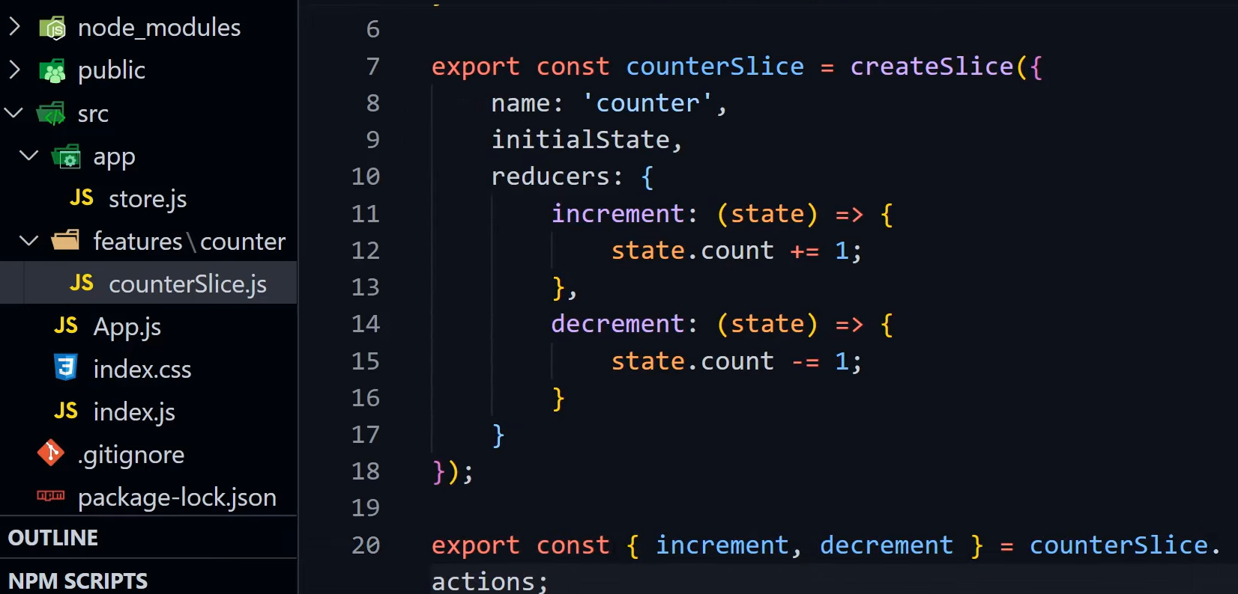

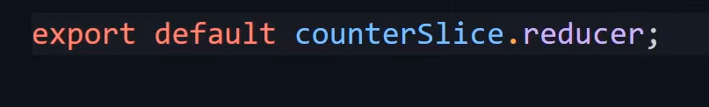

Goto store.js

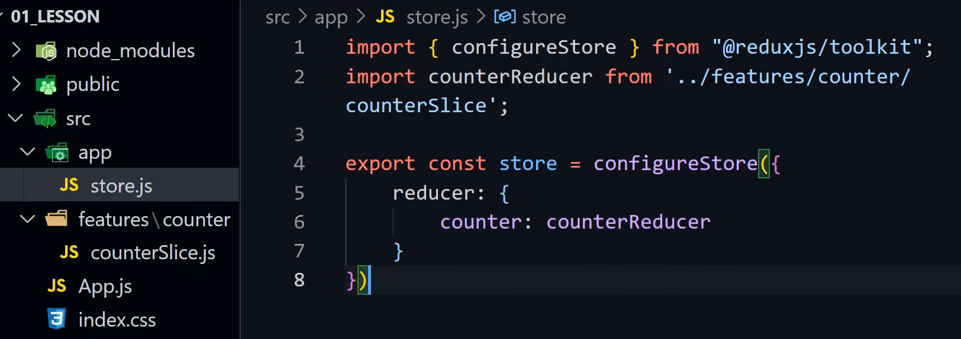

Create counter component

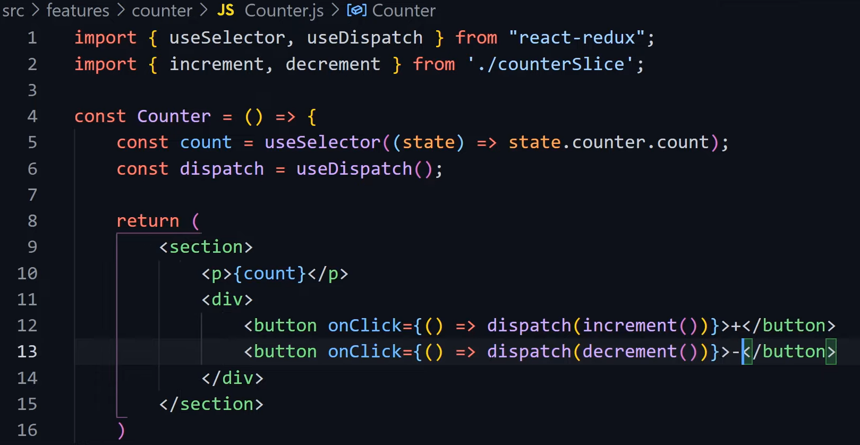

Import to counter to App

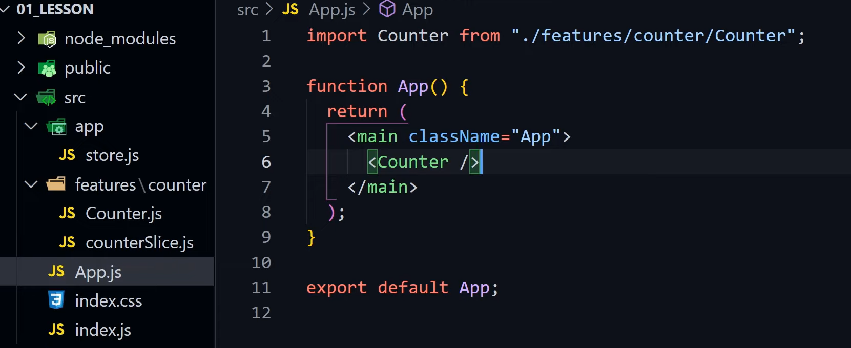

Npm start

It works now. You can add more functionalities. Add reset state.

Create reset action in slice

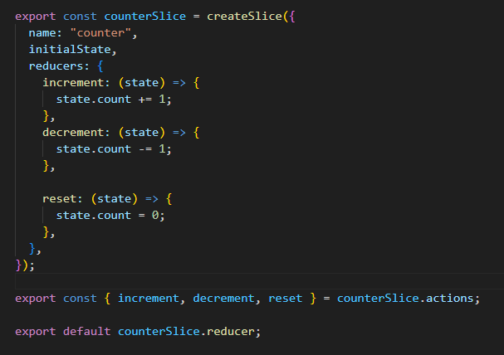

Add to counter component

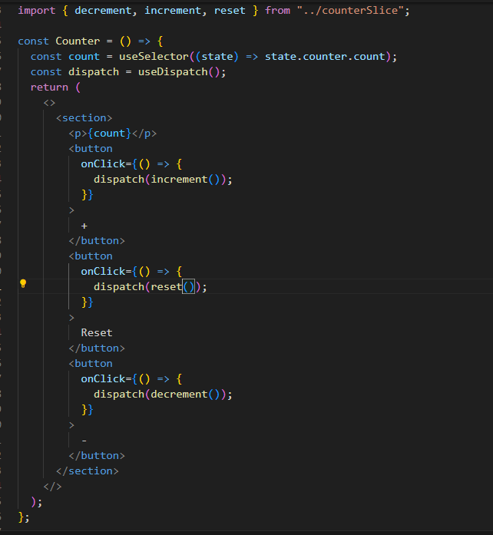

## RTKQuery

Dave Gray

Project dependcies

npm i @fortawesome/react-fontawesome

npm i --save @fortawesome/free-solid-svg-icons

npm i --save @fortawesome/fontawesome-svg-core

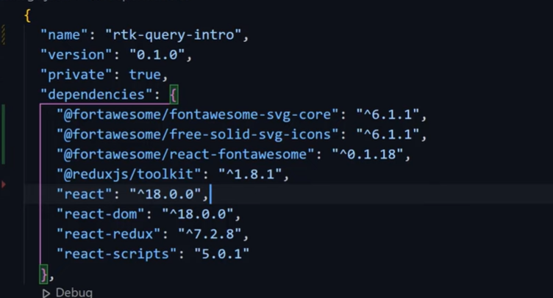

Bu projede json server kullaniliyor. Kurmak icin

npm i json-server -g

ve

json-server --watch src\RTKQuery\data\db.json --port 3500

calisiyorsa gorursun …

Resources

http://localhost:3500/users

http://localhost:3500/posts

Home

http://localhost:3500

Type s + enter at any time to create a snapshot of the database

Watching...

## Dev TOOLS

Cntl+shift +I to open

Cmd + shift +P : open command panel

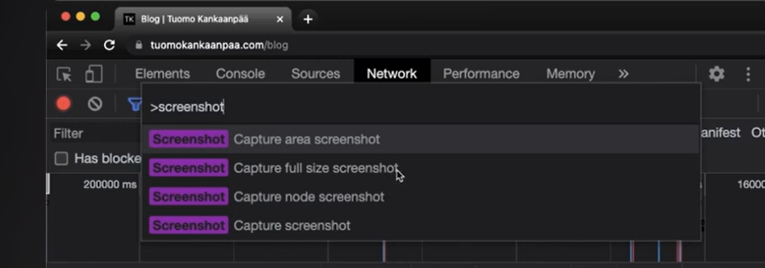

To see local storage

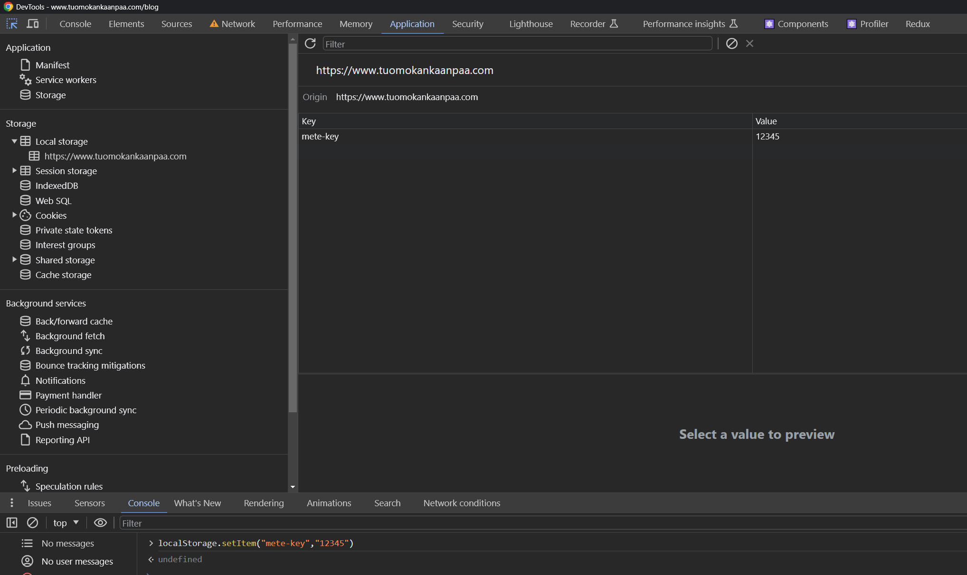

Network disable cahce dene

$0 stands for slected element

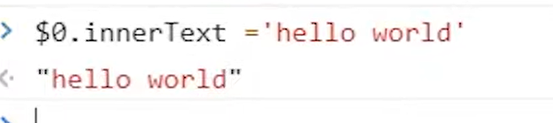



Yukaridaki ni yapinca web page yazabilirsin

## REDUX TOOLKIT & RTK Query

<https://www.youtube.com/watch?v=u3KlatzB7GM&list=PL0Zuz27SZ-6M1J5I1w2-uZx36Qp6qhjKo>

npm install @reduxjs/toolkit react-redux